A Study on User Satisfaction of Village Bathhouses in Rural Areas
- Focusing on Pilot Project of Common Facilities for Rural Seniors -

Han-Kuk Kim¹, Daehan Lee², Gil-Dong³

¹Professor, School of Architecture, Daehan University
²Assistant Professor, University Industry Cooperation Foundation, Minkuk National University
³ Representative Architect, Design and Art Factory

Abstract
The purpose of this study is to evaluate user satisfaction with village bathhouses, selected from a two-year pilot project of common facilities for seniors in rural areas from 2014 to 2015. A survey was conducted using a questionnaire to evaluate user satisfaction, and 96 questionnaires were collected from 10 village bathhouses. User satisfaction was evaluated in five categories with a five-point scale: location and spatial composition; emotions and intimacy; safety; hygiene and equipment; and maintenance and management. The results are as follows. First, scores on hygiene and equipment stood at four points or higher, indicating higher user satisfaction. However, scores on the other four categories were below four points. But when overall user satisfaction was evaluated on a five-point scale, the average score stood at 4.13 out of five points and 89.5 out of 100 points. These findings suggest that users were generally satisfied with the bathhouses. Second, a comparison of bathing patterns from before and after bathhouse construction in villages revealed that 42.7% of residents had previously gone to neighboring villages to bathe. Local bathhouse construction led to an increase in overall bathing frequency, exerting a beneficial effect on hygiene. Third, general user satisfaction correlated more closely with items related to location and spatial composition than items of other categories, indicating that the architectural elements of the bathhouses have a major impact. Finally, access to a bathhouse at all times showed strong correlation with satisfaction levels, suggesting a need for the establishment of more bathhouses throughout rural areas.

Keywords: rural area, common facility for seniors, pilot project, village bathhouse

Corresponding Author: Daehan Lee, Assistant Prof., Minkuk National University, address
Tel: 82-00-000-0000 Fax: 82-00-000-0000
e-mail: dahan@ccku.ac.kr

1. Introduction

1.1. Background and Purpose of Study
Seniors residing in rural areas face the need to repair their old and decrepit homes, and therefore live in inadequate housing where they do not utilize heating in winter due to high costs. Poor housing environments in rural areas are causing rural villages to transform into depopulated villages or marginal villages, bringing about imbalances in regional development.
In addition to these problems of an aging society, poverty, and lonely deaths, disadvantaged rural areas are a blind spot for medical welfare. With the intent of promoting basic housing and security in old age for rural seniors, in addition to expanding health, medical and welfare benefits, Korea’s Ministry of Agriculture, Food and Rural Affairs announced the “Common Facilities for Seniors in Rural Areas Pilot Project” in January 2014 as an alternative welfare model to address the issue of the aging rural population. The pilot project intends to provide a basic residential environment for seniors who are struggling with aging, poverty and lonely death and have difficulty in accessing medical services. Over a period of two years from 2014 to 2015, public facilities for rural seniors in the form of community living homes, common facilities for meals, and public bathhouses have been established as demonstration projects on a national scale (Table 1).

Table 1. The number of common facilities for seniors built under the pilot project from 2014 to 2015 in each area
Area | Total |  |  | Community living home |  | Common meal  facility |  | Village  bathhouse
 | `14 | `15 | Total | `14 | `15 | `14 | `15 | `14 | `15
Sejong | 1 | - | 1 | - | - | - | - | 1 | -
Gyenggi | 2 | 2 | 4 | - | 1 | 1 | 1 | 1 | -
Gangwon | 3 | 2 | 5 | 3 | 2 | - | - | - | -
Chungbuk | 2 | 8 | 10 | - | 4 | 2 | 4 | - | -
Chungnam | 4 | 5 | 9 | 2 | 3 | 1 | 2 | 1 | -
Jeonbuk | 14 | 15 | 29 | 7 | 6 | 7 | 8 | - | 1
Jeonnam | 9 | 8 | 17 | 5 | 4 | 2 | 3 | 2 | 1
Gyeongbuk | 18 | 18 | 36 | 6 | 7 | 8 | 6 | 4 | 5
Gyeonnam | 18 | 11 | 29 | 10 | 6 | 4 | 2 | 4 | 3
Jeju | 1 | 4 | 5 | - | - | 1 | 2 | - | 2
Total | 72 | 73 | 145 | 33 | 33 | 26 | 28 | 13 | 12

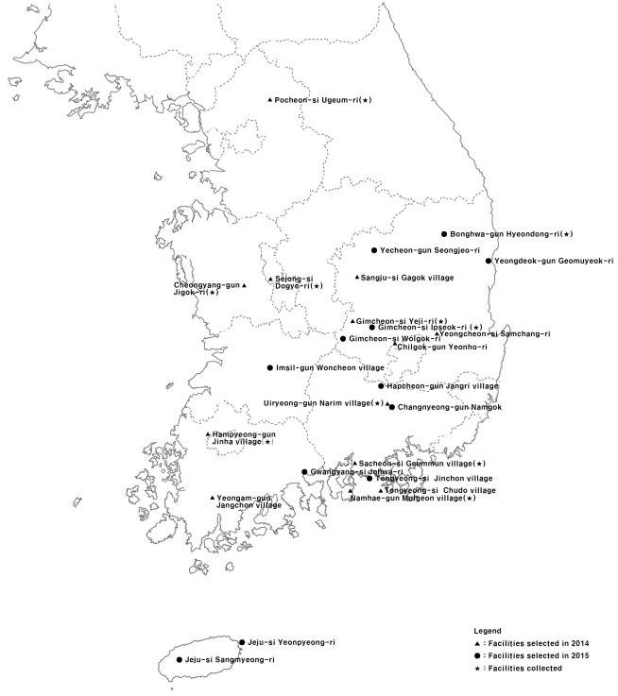
Fig. 1. Area distribution of bathhouses in pilot project

Among the common facilities for seniors constructed in rural areas in the two-year pilot project from 2014 to 2015, village bathhouses are the focus of this study. The purpose of this study is to evaluate user satisfaction with the bathhouses. A survey was conducted using a questionnaire to evaluate user satisfaction.
The word “bathhouse” in the context of the pilot project translates literally to “small bathhouse.” They are public facilities for all village residents, but their size is small due to a low number of users, as they are constructed in villages in rural areas. Therefore, the small bathhouses of the pilot project are referred to as “village bathhouses” in this study.

1.2 Research subjects and methods
The subjects of this study were selected from 28 village bathhouses constructed as part of the pilot project of common facilities for the elderly in rural areas from 2014 to 2015. Through a field survey, a questionnaire- based survey was conducted at bathhouses currently in operation. Facilities with completed construction but an operation period of less than one month were excluded from the research.

2. Establishment background of village bathhouses

Bathing is an extremely individual and private behavior that entails the exposure of one’s uncovered body. The public bathhouse is a public space where this type of private behavior occurs in the company of total strangers who use bath water together. Thus, in rural areas, it is a place where residents can meet each other and develop community.
One survey¹⁾ on urban and rural seniors’ bathing habits indicated that 33.8% of rural seniors bathe daily, compared with 30.6% of urban seniors. However, the largest proportion of urban seniors, 36.1%, bathes every other day. This suggests that rural seniors who bathe every day (full-body baths and showers included) do so because they engage in farm labor.
Furthermore, the public bathhouse is the preferred bathing location among rural seniors (61.4%), while bathing at home is preferred by the majority of urban seniors (63.9%). This is because urban homes tend to have better-equipped bathrooms than rural homes,²⁾ but rural seniors’ desire to save on heating costs may also be an important factor. Seniors residing in “eup” and “myeon”-designated rural areas report economic hardship (34.7%) as second only to health problems (51.5%) among the difficulties they face; thus, a poor housing environment may also be seen as a factor causing them to prefer bathhouses. ³⁾
The small bathhouses included in this pilot project were preceded by the first small public bathhouse in Anseong-myeon area of Muju county in Jeollabuk-do, Korea. A small public bathhouse for people who had gone out neighboring villages for bathing was designed by Jung Ki-Young⁴⁾ inside the building of the Anseong-myeon office.
.

3. Evaluation of user satisfaction

3.1 User information
This study included 48 men and 48 women for a total of 96 users with a 50-50 gender split.
Responses of how users came to reside in their current villages revealed that 50% were born in their current villages, 24% came to their current villages after marrying men who resided there, 19.8% moved to their current villages, and 5.28% left urban areas to become farmers in the villages.

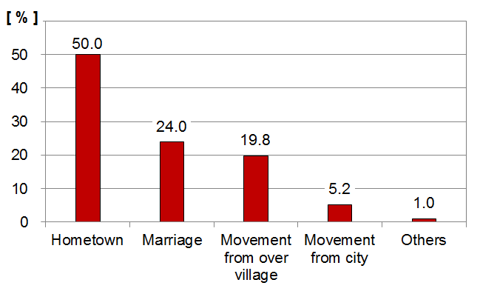
Fig. 2. Residence background

4. Conclusion and suggestions

This study examines a two-year pilot project of common facilities for rural seniors from 2014 to 2015, focusing on village bathhouses. A survey was conducted using a questionnaire to evaluate user satisfaction. 96 questionnaires were collected from 10 village bathhouses selected in the pilot project. User satisfaction was evaluated based on five categories: location and spatial composition; emotions and intimacy; safety; hygiene and equipment; and maintenance and management.

Notes
- One bathhouse per one village was selected.
- Reference 1)
- Reference 2)
- A Korean architect was born in 1945 and died in 2011. He emphasized societal responsibility of architects and participated in public projects. This small-size bathhouse was constructed as one of Muju project (1996-2006).

References
- Back, S. (2005), A Design of Public Bath as Playground for Social Equality, Hanyang University, Master Thesis, p.28.
- Cho, M. Y. (2008), The study of desiring and status of life the age in urban and agricultural village, Sogang University, Master Thesis, pp.45-47.
- Nam, Y. (2015) A Policy of Senior Community Center in Rural Area-Focused on Pilot Project of Senior Community Center, Journal of Korea Institute of Rural Architecture, 17(1), pp.121-128

** 참고문헌 작성 순서는 연도가 아니라 알파벳순서입니다.

